TRIBHUVAN UNIVERSITY

**PATAN MULTIPLE CAMPUS**

PATAN DHOKA, LALITPUR

**DIGITAL LOGIC (BIT 103)**

**LAB 4**

|  |  |
| --- | --- |
| **SUBMITTED BY** | **SUBMITTED TO** |
|  |  |
| NAME: SURESH DAHAL | JYOTI PRAKASH CHAUDHARY |
| CLASS: BIT – I / I |  |
| ROLL NO: 23 | ………………………… |
| DATE: 2080/10/17 | CHECKED BY |

**TITLE: STATE AND PROVE DE-MORGAN’S THEOREMS WITH TRUTH TABLE AND LOGIC DIAGRAM**

1. **(X+Y)’ = X’. Y’**
2. **OBJECTIVE**

* To practically prove De-Morgan’s theorems with logic diagram and truth table.

1. **REQUIREMENTS**
   * 1. Digital Learning Kit and Simulator
     2. 1 NOR gate, 2 NOT gates, 1 AND gate
     3. Connecting wires
     4. Interactive / Sequence generator as input
     5. LED as output
2. **THEORY**

* + - 1. **INTRODUCTION**

De Morgan's theorem states that complementing the result of OR'ing variables together is equivalent to AND'ing the complements of the individual variables.

* + - 1. **LOGIC EXPRESSION**

(X+Y)’ = X’.Y’

* + - 1. **CIRCUIT DIAGRAM**

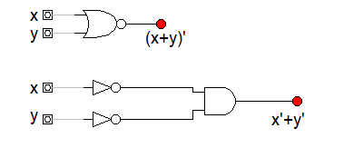

* + - 1. **TRUTH TABLE**

|  |  |  |  |
| --- | --- | --- | --- |
| X | Y | (X+Y)’ | X’.Y’ |
| 0 | 0 | 1 | 1 |
| 0 | 1 | 0 | 0 |
| 1 | 0 | 0 | 0 |
| 1 | 1 | 0 | 0 |

1. **CONCLUSION**

Hence, by doing this practical experiment, we have practically verified that complementing the result of OR'ing variables together is equivalent to AND'ing the complements of the individual variables.

1. **(X.Y)’ = X’ + Y’**
2. **OBJECTIVES**

* To practically prove De-Morgan’s theorems with logic diagram and truth table.

1. **REQUIREMENTS**
   * 1. Digital Learning Kit and Simulator
     2. 1 NAND gate, 2 NOT gates, 1 OR gate
     3. Connecting wires
     4. Interactive / Sequence generator as input
     5. LED as output
2. **THRORY**
   * + 1. **INTRODUCTION**

De Morgan's theorem states that complementing the result of AND'ing variables together is equivalent to OR'ing the complements of the individual variables.

1. **LOGIC EXPRESSION**

(X.Y)’ = X’+Y’

1. **CIRCUIT DIAGRAM**

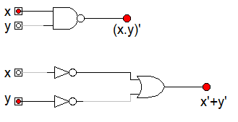

1. **TRUTH TABLE**

|  |  |  |  |
| --- | --- | --- | --- |
| X | Y | (X+Y)’ | X’.Y’ |
| 0 | 0 | 1 | 1 |
| 0 | 1 | 1 | 1 |
| 1 | 0 | 1 | 1 |
| 1 | 1 | 0 | 0 |

**d) CONCLUSION**

Hence, by doing this practical experiment, we have practically verified that complementing the result of AND'ing variables together is equivalent to OR'ing the complements of the individual variables.